DDIM Results for Various Sampling Steps

20 steps, Display every 5 steps
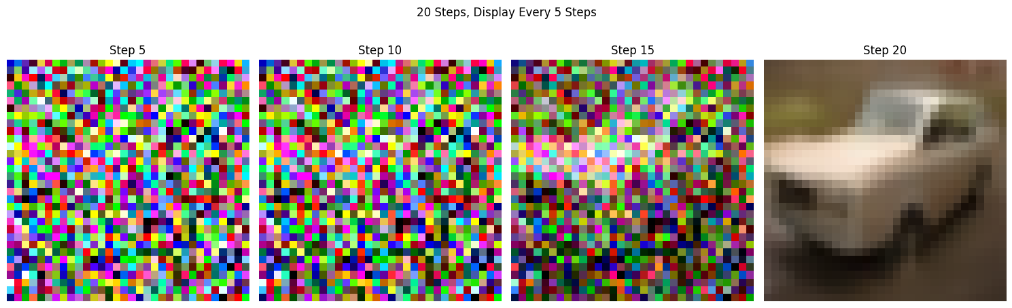
50 steps, Display every 5 steps

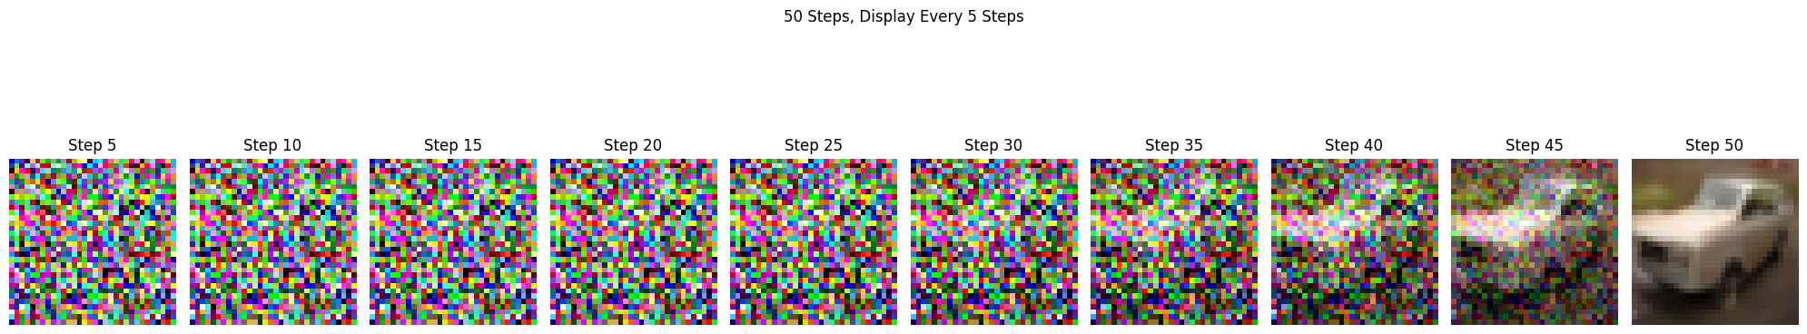
100 steps, Display every 5 steps (last 50)
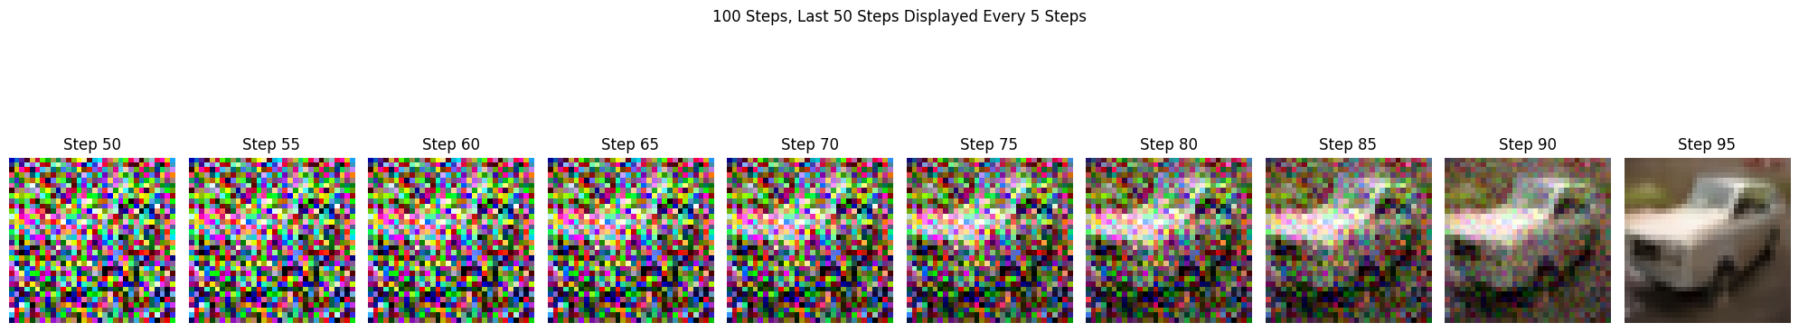
200 steps, Display every 5 steps (last 50)
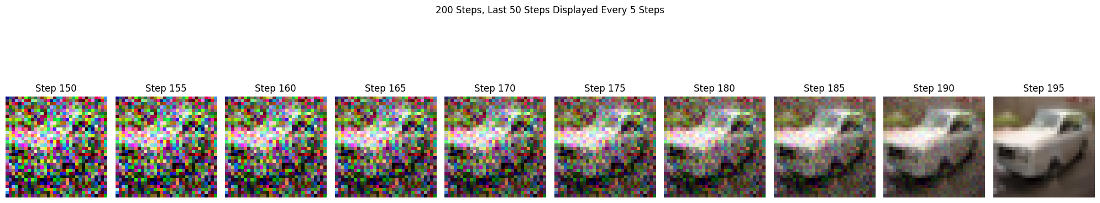

The primary observation to be made here is that with more steps overall, the slower and more gradual the denoising is. This current step as a fraction of total steps is a comparable function of noise across different step sizes. For instance, 40/50 steps yields the same result as 80/100 steps in terms of denoising progress. The denoising can also happen very quickly as shown in the example with fewer (i.e. 20) steps. This simply means that more noise is removed in one step as opposed to a run with a larger number of overall steps, highlighting DDIM’s ability to accelerate sampling by adjusting the number of steps without significantly sacrificing image quality.

